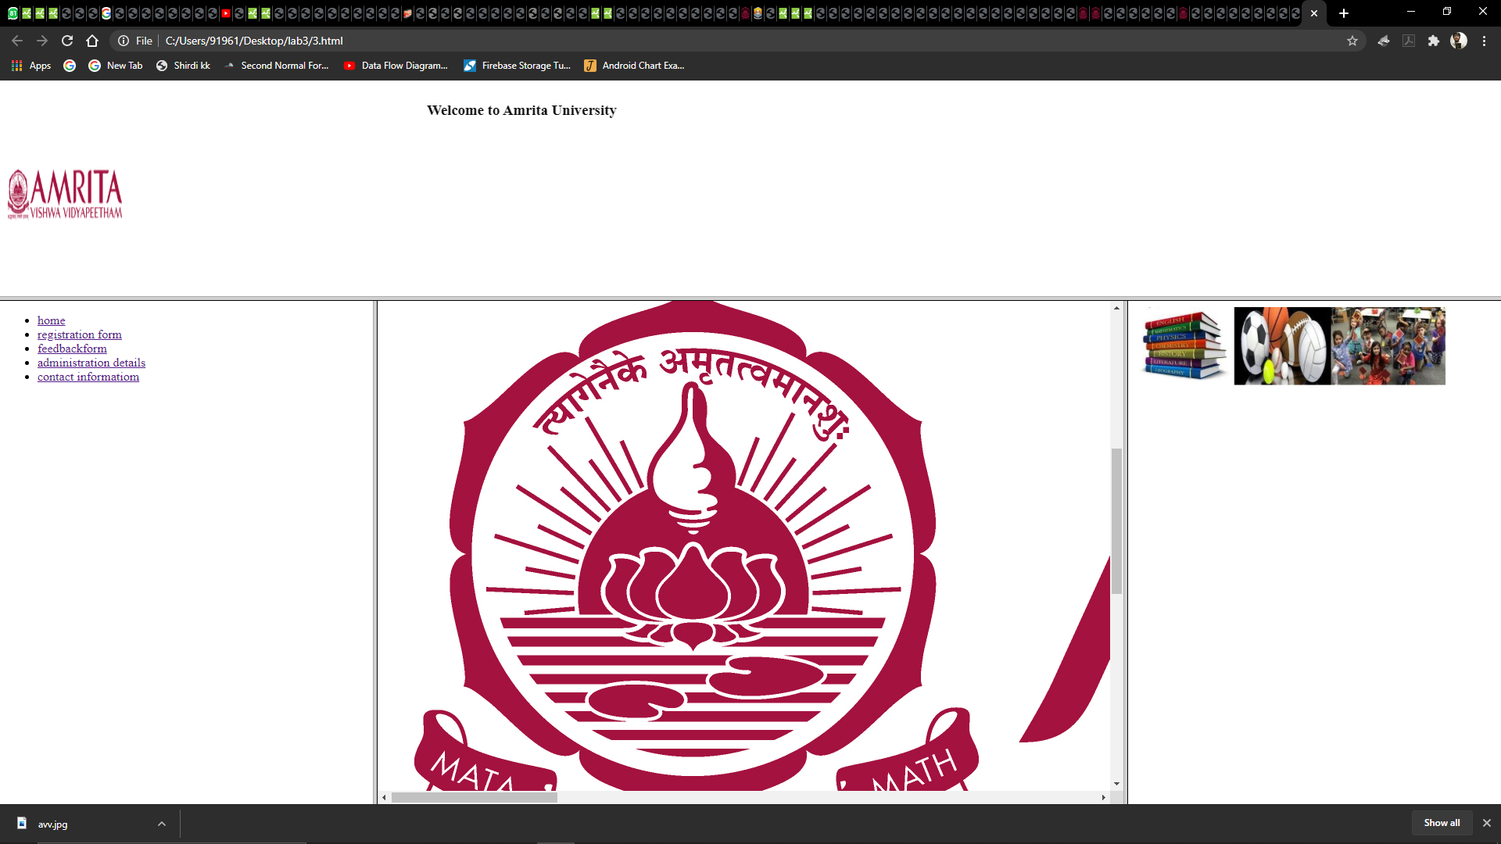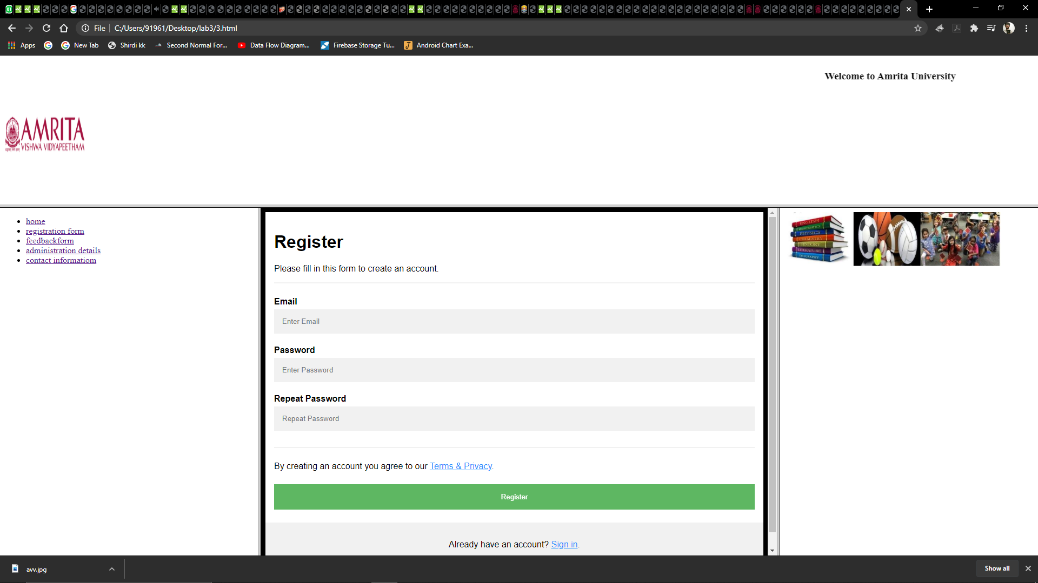

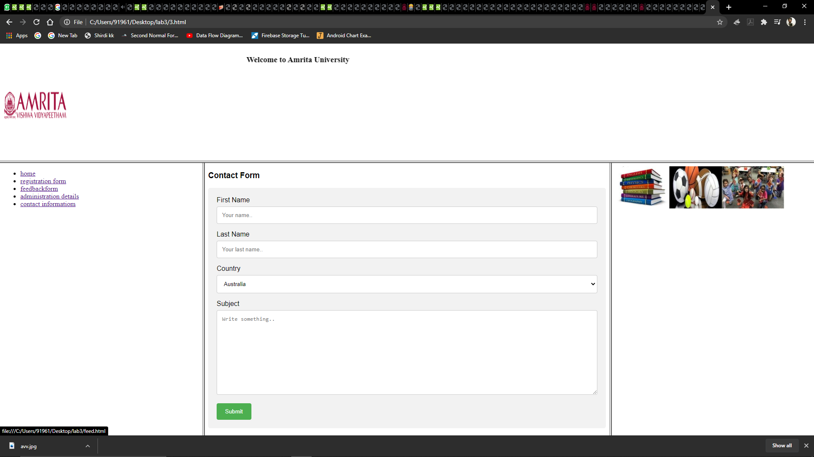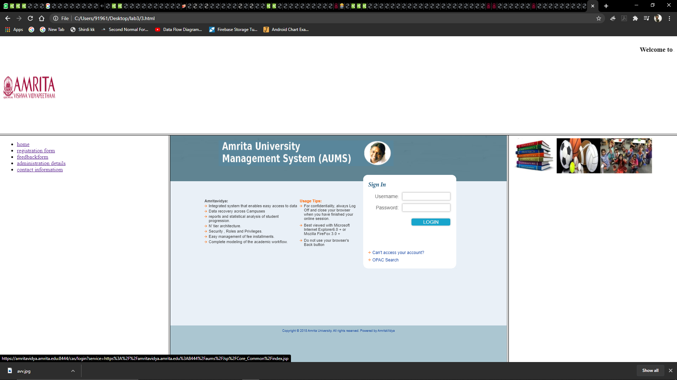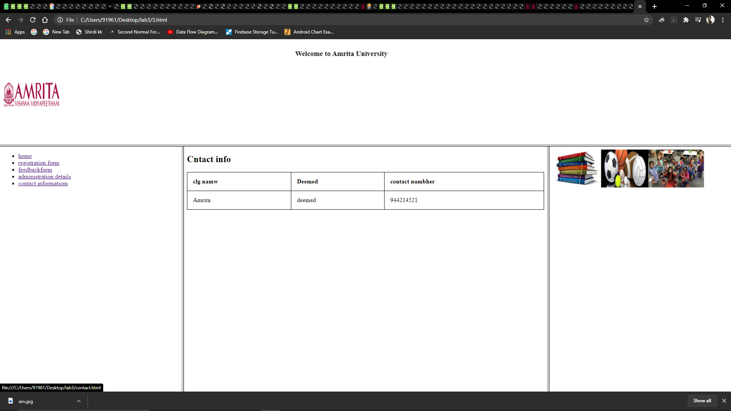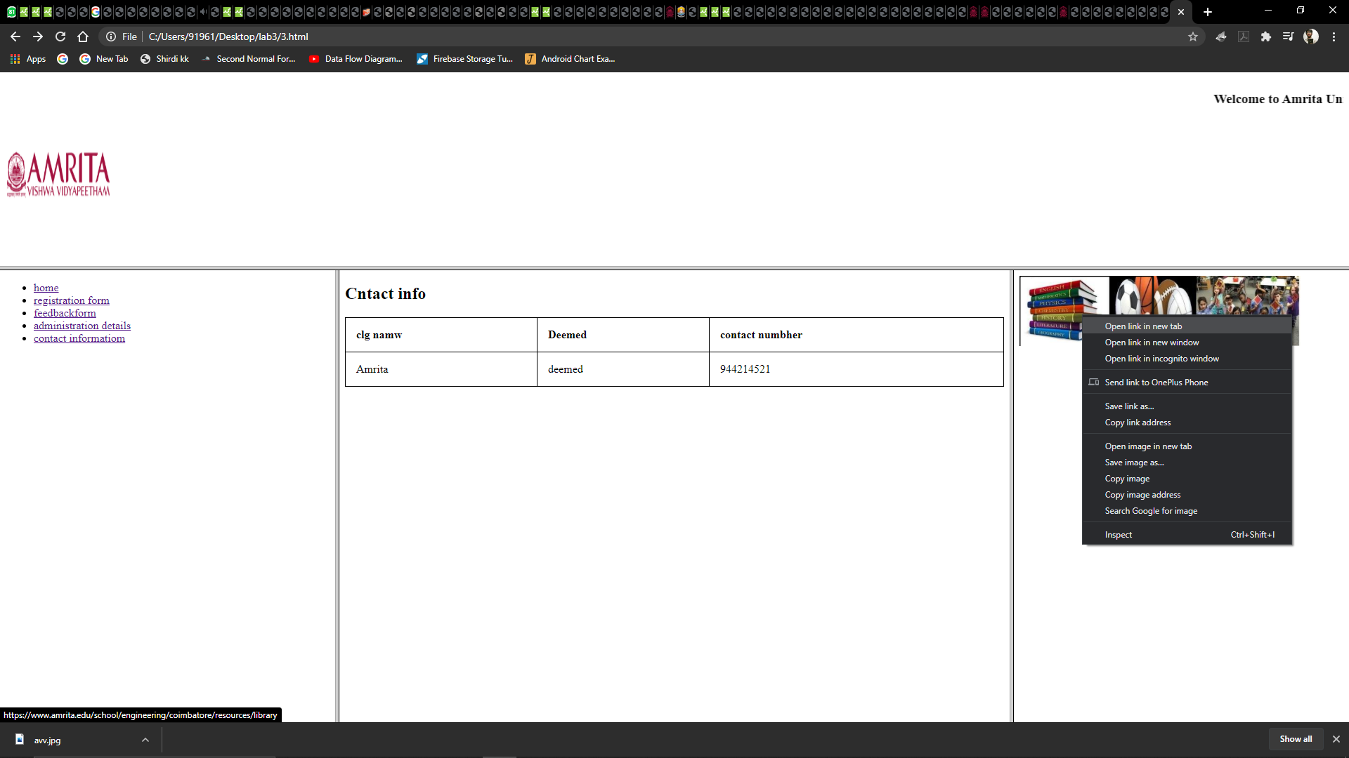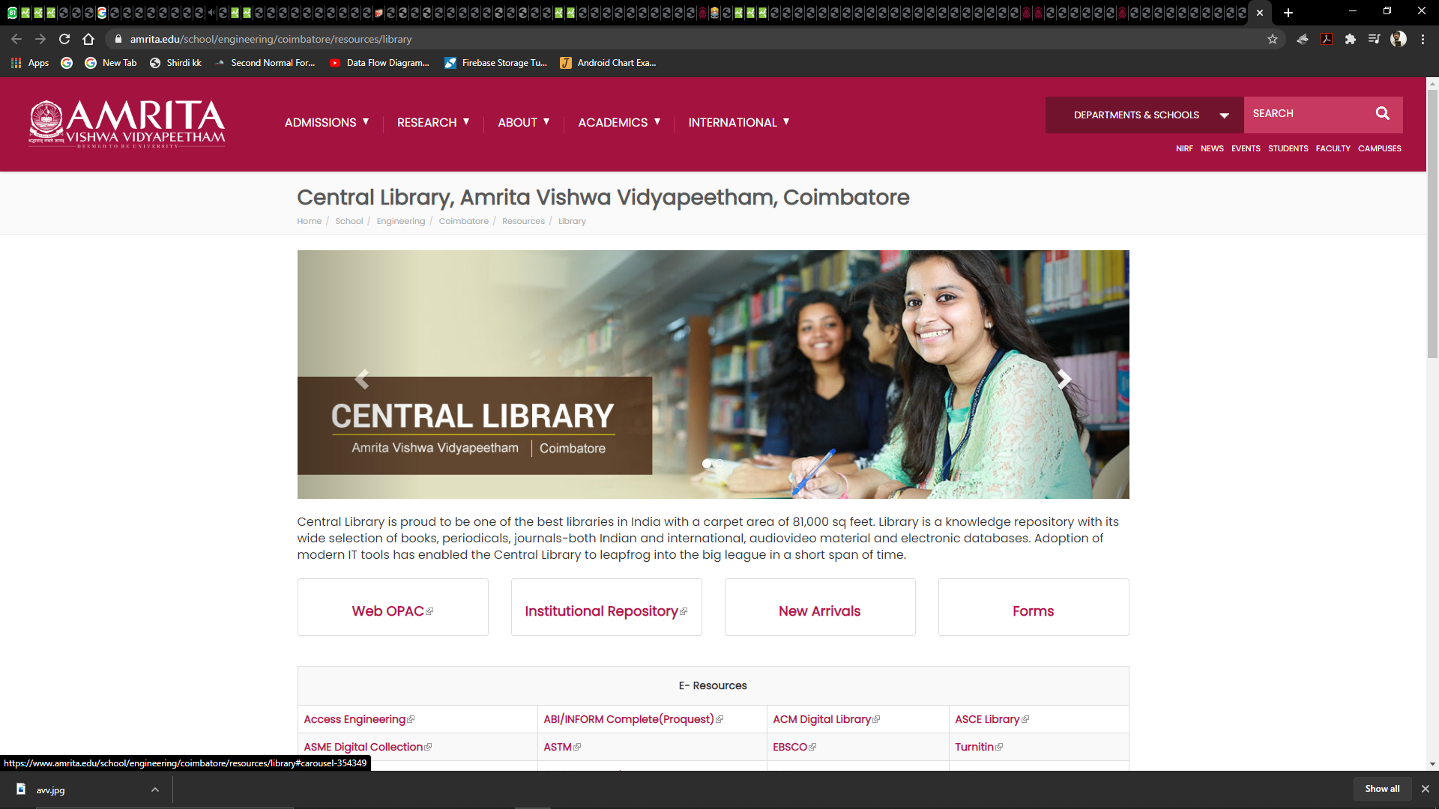

<!DOCTYPE html>

<html>

   <head>

      <title>HTML Frames</title>

   </head>

   <frameset rows = "30%,70%",>

      <frame name = "top" src = "5.html" />

      <frame name = "main" src = "lab1.html" />

      <noframes>

         <body>Your browser does not support frames.</body>

      </noframes>

   </frameset>

</html>

<!DOCTYPE html>

<html>

<marquee behavior="scroll" direction="left"><h3> Welcome to Amrita University</h3> </marquee>

<body><img src="avv.jpg"  align="center" width="150" height="150">

</body>

</html>

<html>

<head>

  <title> first </title>

</head>

<frameset cols = "25%,50%,25%",>

  <frame name = "left" src = "6.html" />

  <frame name = "center" src = "avv.jpg", width="170", height="170"/>

  <frame name="right" src="7.html"/>

  <noframes>

     <body>Your browser does not support frames.</body>

  </noframes>

</frameset>

</html>

<!DOCTYPE html>

<html>

   <head>

      <title>Hyper links</title>

   </head>

   <body>

    <ul>

        <li><a href="avv.jpg" target="center"> home</a></li>

        <li><a href="4.html" target="center">registration form</a></li>

        <li><a href="feed.html" target="center">feedbackform</a></li>

        <li><a href="https://amritavidya.amrita.edu:8444/cas/login?service=https%3A%2F%2Famritavidya.amrita.edu%3A8444%2Faums%2FJsp%2FCore_Common%2Findex.jsp" target="center">administration details</a></li>

        <li><a href="contact.html" target="center">contact informatiom</a></li>

      </ul>

   </body>

</html>

<!DOCTYPE html>

<html>

<head>

</head>

<body>

<div>

<img src="3.jpg" usemap="#book" style="width: 598" height="195px">

<map name="book">

  <area shape="books" coords="0,0,190,184"  href="https://www.amrita.edu/school/engineering/coimbatore/resources/library">

  <area shape="books" coords="191,2,375,179"  href="https://www.amrita.edu/tags/sports">

  <area shape="books" coords="377,2,595,180"  href="https://www.amrita.edu/tags/student-achievements">

</map>

</div>

</body>

</html>